Implementation of Country-Based Ad & Third-Party Script Control using AWS CloudFront

1. Objective
To comply with data protection regulations and improve user experience, ads and third-party tracking scripts are shown only for Indian users, while being disabled for users outside India.
This ensures:
- Targeted ad display
- Reduced unnecessary script execution
- Improved page performance
- Compliance with privacy regulations

2. Architecture Overview

Components:
- AWS CloudFront
  - Distributes web content globally.
  - Injects CloudFront-Viewer-Country header based on user’s request location.
- Origin Server / Application
  - Receives requests with CloudFront-Viewer-Country.
  - Decides whether to serve pages with ads & scripts (for India) or without (for others).
- End Users
  - Indian users: Receive full content with ads and analytics.
  - Non-Indian users: Receive content without ads and third-party scripts.

3. Flowchart 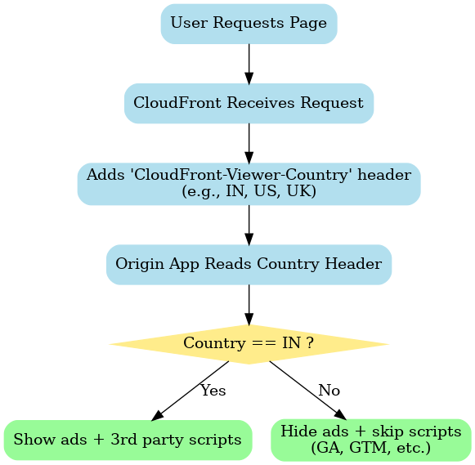

4. Implementation Details

CloudFront Configuration:
- Cache Policy: Include CloudFront-Viewer-Country header.
- Origin Request Policy: Forward CloudFront-Viewer-Country.
- Behavior:
  - Cached separately per country (so ads vs. no ads versions are served efficiently).

Application Logic:
- Read CloudFront-Viewer-Country header.
- If IN (India):
  - Inject ads & tracking scripts.
- Else:
  - Exclude following third-party scripts:
    - google-analytics
    - googletagservices
    - partner.googleadservices
    - tpc.googlesyndication
    - pagead2.googlesyndication
    - googletagmanager
    - securepubads
    - pubmatic
    - comscore

5. Benefits
- ✅ Compliance – Ads limited to India, reducing GDPR/CCPA exposure.
- ✅ Performance – Faster load times outside India (no ad/analytics scripts).
- ✅ Security – Reduced third-party tracking for non-Indian traffic.
- ✅ Scalability – CloudFront handles country detection globally.

6. Future Enhancements
- Add per-country ad rules (e.g., enable ads in India + Singapore).
- Log requests per country for analytics.
- Integrate feature flag system for finer control of third-party scripts.

